**UNIVERSITY SCHOOL OF INFORMATION & COMMUNICATION TECHNOLOGY (USICT)**

# **GURU GOBIND SINGH INDRAPRASTHA**

# **UNIVERSITY**

## **Sector 16 C, Dwarka, Delhi, 110078**



**FrontEnd and Design**

#### (IT 664)

**Submitted To: Submitted By:**

**Dr. Juhee Arora Nabin Kumar Pal**

**Enroll no.:07016404524**

**MCA(SE) Sem-2**

**Section: 2**

**Index**

| **S. No.** | **Program** | **Date** | **Signature** |
| --- | --- | --- | --- |
| 1 | What is Frontend? Write a note on HTML, CSS and JavaScript |  |  |
| 2 | Using HTML Tags, design your own curriculum vitae |  |  |
| 3 | Using HTML Tags, redesign the home page of GGSIP university |  |  |
| 4 | Write an XML Program to display Student profile having age like student roll no., name, age, semester, email id, phone number, department name, apply and validate using DTD |  |  |
| 5 | Write a JavaScript Program to check whether an input number is palindrome number or not |  |  |
| 6 | Write a Generic Servlet program to display your own Enrollment number and Name using Apache Tomcat server |  |  |
| 7 | Write a HTTP Servlet program to display all the HTTP Request Header parameters |  |  |
| 8 | Write a HTTP Servlet program to create a Cookie |  |  |
| 9 | Write a JDBC Program to fetch the employees records from the Employee table designed in MS Access. The Table should have fields like: Employee ID, Name, DOB, Address, Department, DOJ, Position etc. |  |  |
| 10 | Create your portfolio website using LocalWP and WordPress |  |  |

**Program No.1**

**Aim:** What is Frontend? Write a note on HTML, CSS and JavaScript.

### **Code:**

### ****What is Frontend?****

The **frontend** (also known as "client-side") of a web application is the part that users interact with directly in their web browsers. It includes everything that users experience visually on the website: **text, images, sliders, buttons, navigation menus, forms**, and more.

Frontend development involves building the **user interface (UI)** and ensuring the **user experience (UX)** is smooth, responsive, and accessible. It focuses on the **layout, design, and interactivity** of a website using technologies like **HTML, CSS, and JavaScript**.

### ****HTML (t MarkupHyperTex Language)****

HTML is the **standard markup language** for creating web pages.It defines the **structure and content** of a webpage using **tags** such as <h1>, <p>, <img>, <a>, <table>, etc.

HTML forms the **skeleton** of the website.

**Example:**

<h1>Welcome to My Website</h1><p>This is a paragraph of text.</p>

### ****CSS (Cascading Style Sheets)****

CSS is used to **style** and lay out web pages — for example, to change fonts, colors, spacing, and layout.

It enhances the visual appearance and is responsible for the **design and aesthetics** of the webpage.

CSS can be applied inline, internally, or externally.

**Example:**

h1 {

color: blue;

text-align: center;

}

### ****JavaScript****

JavaScript is a **programming language** used to add **interactivity** and **dynamic behavior** to websites.

It allows features like **form validation, image sliders, dropdowns, animations, AJAX calls**, etc.

JavaScript can respond to user events (e.g., button clicks) without reloading the page.

**Example:**

function showMessage() {

alert("Hello! This is a JavaScript alert.");

}

**Program No.2**

**Aim:** Using HTML Tags, design your own curriculum vitae

**Code:**

<!DOCTYPE html>

<html>

<head>

<title>My Curriculum Vitae</title>

</head>

<body>

<h1>Curriculum Vitae</h1>

<hr>

<h2>Personal Information</h2>

<p><strong>Name:</strong> Nabin Kumar Pal</p>

<p><strong>Email:</strong> my.email@example.com</p>

<p><strong>Phone:</strong> +91-XXXXXXXXXX</p>

<p><strong>Address:</strong> my addrees blockno., landmark etc</p>

<h2>Career Objective</h2>

<p>

To secure a challenging position in a reputable organization to expand my learnings, knowledge, and skills.

</p>

<h2>Academic Qualifications</h2>

<ul>

<li>MCA – GGSIPU University – 2024–2026</li>

<li>B.Sc – DU university – 2020–2023</li>

<li>12th – CBSE – 2019–2020</li>

</ul>

<h2>Technical Skills</h2>

<ul>

<li>HTML, CSS, JavaScript</li>

<li>Java, Python, C++</li>

<li>MySQL, MongoDB</li>

<li>Git, GitHub</li>

</ul>

<h2>Projects</h2>

<ol>

<li><strong>YouTube Comment Analyzer:</strong> An AI-based web app that summarizes viewer feedback and suggests new topics.</li>

<li><strong>Portfolio Website:</strong> Designed a personal portfolio using HTML, CSS, and JavaScript.</li>

</ol>

<h2>Strengths</h2>

<ul>

<li>Quick Learner</li>

<li>Team Player and want to Lead</li>

<li>Good Communication Skills</li>

</ul>

<h2>Hobbies</h2>

<ul>

<li>Gaming</li>

<li>Coding Projects</li>

<li>Reading Tech Blogs</li>

</ul>

<h2>Declaration</h2>

<p>I hereby declare that all the information provided above is true to the best of my knowledge and belief.</p>

<p><strong>Place:</strong> Delhi</p>

<p><strong>Date:</strong> 05 May 2025</p>

</body>

</html>

**Output:**

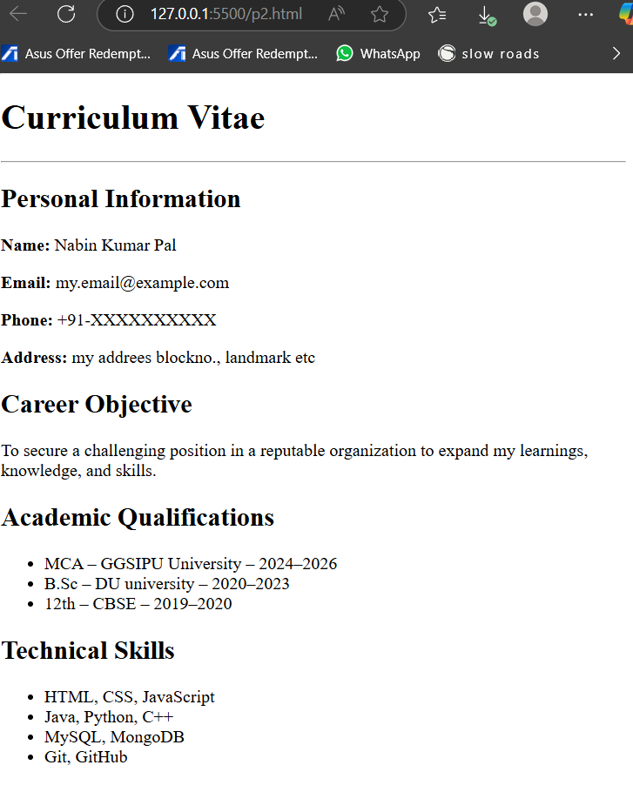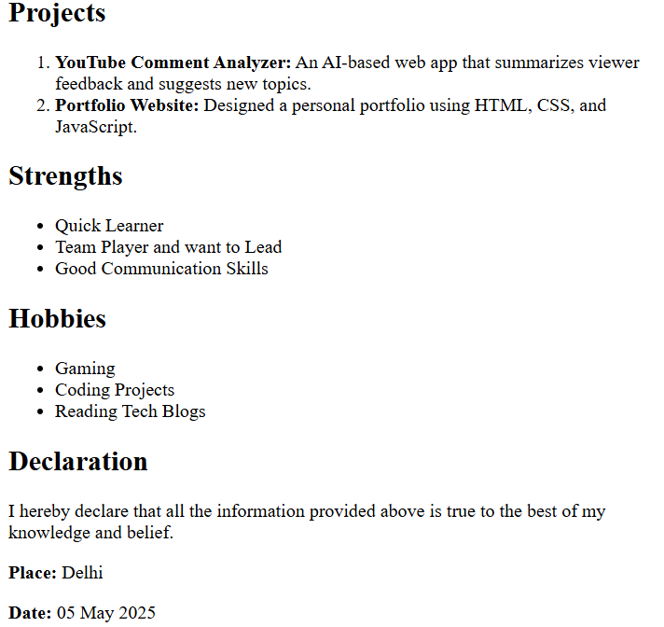

**Program No.3**

**Aim:** Using HTML Tags, redesign the home page of GGSIP university.

**Code:**

<!DOCTYPE html>

<html lang="en">

<head>

<meta charset="UTF-8">

<meta name="viewport" content="width=device-width, initial-scale=1">

<title>IPU Website</title>

<style>

/* Reset and base styles */

* {

margin: 0;

padding: 0;

box-sizing: border-box;

font-family: "Segoe UI", sans-serif;

}

body {

background-color: #f5f5f5;

color: #333;

}

/* Navbar styling */

.navbar {

display: flex;

justify-content: space-between;

align-items: center;

background-color: #002244;

padding: 10px 20px;

flex-wrap: wrap;

}

.nav-left {

display: flex;

align-items: center;

flex-wrap: wrap;

gap: 10px;

}

.nav-left img {

height: 40px;

margin-right: 15px;

}

.nav-left a {

color: white;

text-decoration: none;

font-size: 15px;

transition: color 0.3s;

padding: 8px 12px;

display: inline-block;

}

.nav-left a:hover {

color: #ffcc00;

}

.nav-right {

display: flex;

align-items: center;

gap: 10px;

}

.nav-right input {

padding: 6px 10px;

border: none;

border-radius: 4px;

outline: none;

}

/* Dropdown styling */

.dropdown {

position: relative;

}

.dropdown-menu {

display: none;

position: absolute;

top: 100%;

left: 0;

background-color: #003366;

min-width: 160px;

border-radius: 4px;

z-index: 1000;

}

.dropdown-menu li {

list-style: none;

}

.dropdown-menu li a {

color: white;

padding: 10px 16px;

text-decoration: none;

display: block;

white-space: nowrap;

}

.dropdown-menu li a:hover {

background-color: #004080;

}

.dropdown:hover .dropdown-menu {

display: block;

}

/* Header styling */

header .logo-bg {

background-color: #003366;

color: white;

padding: 40px 20px;

text-align: center;

border-radius: 0 0 12px 12px;

}

header h1 {

font-size: 2rem;

}

header p {

font-size: 1.2rem;

margin-top: 10px;

}

/* Table styling */

.college-list {

padding: 20px;

overflow-x: auto;

}

table {

width: 100%;

border-collapse: collapse;

background-color: white;

box-shadow: 0 0 10px rgba(0,0,0,0.1);

border-radius: 12px;

overflow: hidden;

}

th, td {

padding: 16px;

text-align: left;

border-bottom: 1px solid #ddd;

}

thead {

background-color: #003366;

color: white;

}

tbody tr:hover {

background-color: #f0f8ff;

}

@media (max-width: 768px) {

.nav-left, .nav-right {

width: 100%;

text-align: center;

margin-bottom: 10px;

flex-direction: column;

}

.nav-left {

justify-content: center;

}

.nav-right input {

width: 80%;

}

.dropdown-menu {

position: static;

}

}

</style>

</head>

<body>

<nav class="navbar">

<div class="nav-left">

<img src="http://ipu.ac.in/style/head_foot_img/220px-usemGuru_Gobind_Singh_Indraprastha_University12.png" alt="GGSIPU"> <div class="dropdown">

<a href="#">Admissions</a>

<ul class="dropdown-menu">

<li><a href="#">Undergraduate</a></li>

<li><a href="#">Postgraduate</a></li>

<li><a href="#">Ph.D</a></li>

</ul>

</div>

<div class="dropdown">

<a href="#">Academics</a>

<ul class="dropdown-menu">

<li><a href="#">Departments</a></li>

<li><a href="#">Curriculum</a></li>

<li><a href="#">Calendar</a></li>

</ul>

</div>

<div class="dropdown">

<a href="#">Examinations</a>

<ul class="dropdown-menu">

<li><a href="#">Datesheet</a></li>

<li><a href="#">Results</a></li>

<li><a href="#">Rechecking</a></li>

</ul>

</div>

<a href="#">Administration</a>

<a href="#">Students</a>

<a href="#">Vice Chancellor</a>

<a href="#">Quick Links</a>

</div>

<div class="nav-right">

<input type="text" placeholder="Search...">

<img src="http://ipu.ac.in/style/head_foot_img/shlvrlogo.png" alt="25 years of ipu" style="height:60px;">

</div>

</nav>

<header>

<div class="logo-bg">

<h1>Guru Gobind Singh Indraprastha University</h1>

<p>Affiliated Colleges List</p>

</div>

</header>

<div id="img" style="height: 50vh; display: flex; justify-content: center; align-items: center; background: #eee;">

<img id="slideshow" src="first.jpg" alt="" style="max-height: 100%; max-width: 100%; border-radius: 8px;">

</div>

<main>

<section class="college-list">

<table>

<thead>

<tr>

<th>Institute Name</th>

<th>Institute Code</th>

<th>Location</th>

</tr>

</thead>

<tbody>

<tr>

<td>MAIT - Maharaja Agrasen Institute of Technology</td>

<td>132</td>

<td>Rohini, Delhi</td>

</tr>

<tr>

<td>BVP - Bharati Vidyapeeth's College of Engineering</td>

<td>125</td>

<td>Paschim Vihar, Delhi</td>

</tr>

<tr>

<td>MSIT - Maharaja Surajmal Institute of Technology</td>

<td>131</td>

<td>Janakpuri, Delhi</td>

</tr>

</tbody>

</table>

</section>

</main>

<footer style="background-color:darkblue; color:white; height:50px;">© 2022 GURU GOBIND SINGH INDRAPRASTHA UNIVERSITY, DELHI 110078. All Rights Reserved.</footer>

</body>

</html>

**Output:**

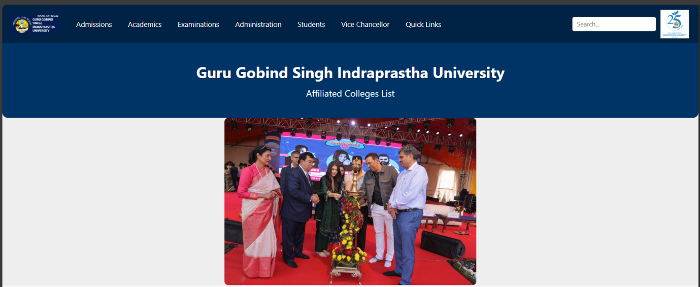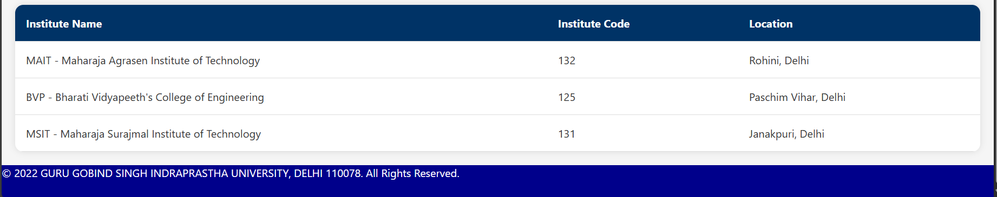

**Program No.4**

**Aim:** Write an XML Program to display Student profile having age like student roll no., name, age, semester, email id, phone number, department name, apply and validate using DTD.

**Code:**

student.xml:

<?xml version="1.0" encoding="UTF-8"?>

<!DOCTYPE studentProfile SYSTEM "student.dtd">

<studentProfile>

<student>

<rollNo>102345</rollNo>

<name>Nabin Kumar Pal</name>

<age>22</age>

<semester>4</semester>

<email>nabin@example.com</email>

<phone>9876543210</phone>

<department>CSE</department>

<applied>true</applied>

</student>

</studentProfile>

student.dtd:

<!ELEMENT studentProfile (student+)>

<!ELEMENT student (rollNo, name, age, semester, email, phone, department, applied)>

<!ELEMENT rollNo (#PCDATA)>

<!ELEMENT name (#PCDATA)>

<!ELEMENT age (#PCDATA)>

<!ELEMENT semester (#PCDATA)>

<!ELEMENT email (#PCDATA)>

<!ELEMENT phone (#PCDATA)>

<!ELEMENT department (#PCDATA)>

<!ELEMENT applied (#PCDATA)>

**Output:**

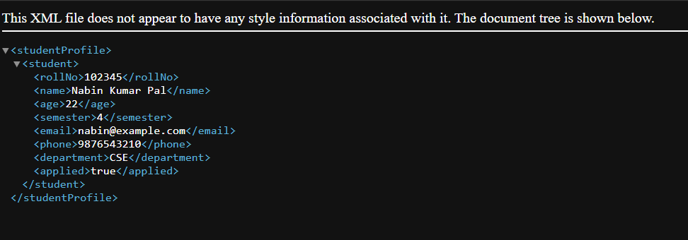

**Program No.5**

**Aim:** Write a JavaScript Program to check whether an input number is palindrome number or not.

**Code:**

<!DOCTYPE html>

<html>

<head>

<title>Palindrome Checker</title>

</head>

<body>

<h2>Palindrome Number Checker</h2>

<input type="number" id="numberInput" placeholder="Enter a number">

<button onclick="checkPalindrome()">Check</button>

<p id="result"></p>

<script>

function checkPalindrome() {

const num = document.getElementById("numberInput").value;

const reversed = num.split('').reverse().join('');

if (num === reversed) {

document.getElementById("result").innerText = `${num} is a palindrome number.`;

} else {

document.getElementById("result").innerText = `${num} is NOT a palindrome number.`;

}

} </script></body>

</html>

**Output:**

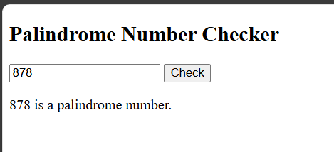

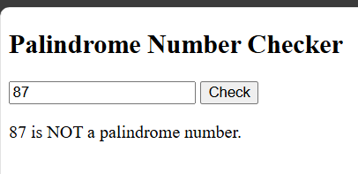

**Program No.6**

**Aim:**Write a JSP Program to auto refresh a page.

**Code:**

<%@ page language="java" contentType="text/html; charset=UTF-8" pageEncoding="UTF-8"%>

<!DOCTYPE html>

<html>

<head>

<title>Auto Refresh JSP Page</title>

<!-- Refresh every 5 seconds -->

<meta http-equiv="refresh" content="5">

</head>

<body>

<h2>This page auto-refreshes every 5 seconds</h2>

<p>Current time: <%= new java.util.Date() %></p>

</body>

</html>

**Output:**

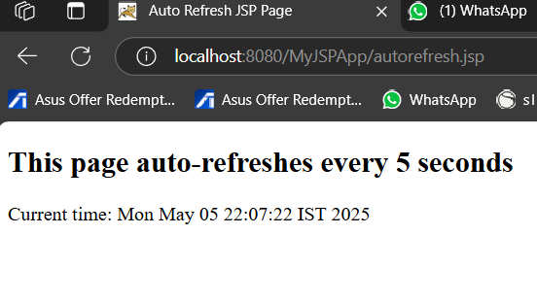

**Program No.7**

**Aim:** Write a JSP Program to upload file into server.

**Code:**

<%@ page import="java.io.*" %>

<%@ page import="javax.servlet.*" %>

<%@ page import="javax.servlet.http.*" %>

<%@ page contentType="text/html;charset=UTF-8" language="java" %>

<html>

<head>

<title>File Upload Form</title>

</head>

<body>

<h2>Upload a File</h2>

<form action="upload.jsp" method="post" enctype="multipart/form-data">

Select File: <input type="file" name="file"><br><br>

<input type="submit" value="Upload">

</form>

<%

if ("POST".equalsIgnoreCase(request.getMethod())) {

String uploadPath = application.getRealPath("/") + "uploads";

File uploadDir = new File(uploadPath);

if (!uploadDir.exists()) uploadDir.mkdir();

Part filePart = request.getPart("file"); // Multipart form

String fileName = filePart.getSubmittedFileName();

String savePath = uploadPath + File.separator + fileName;

try (InputStream input = filePart.getInputStream();

FileOutputStream output = new FileOutputStream(savePath)) {

byte[] buffer = new byte[1024];

int length;

while ((length = input.read(buffer)) != -1) {

output.write(buffer, 0, length);

}

}

out.println("<p style='color:green;'>File uploaded successfully to: uploads/" + fileName + "</p>");

}

%>

</body>

</html>

**Output:**

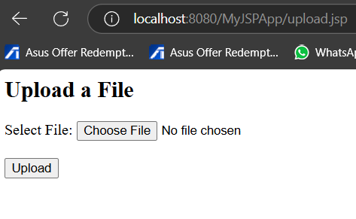

**Program No.8**

**Aim:** Write a Generic Servlet program to display your own Enrollment number and Name using Apache Tomcat server.

**Code:**

Directory formate:

StudentProfileApp

├── WEB-INF

│ ├── web.xml

│ └── classes

│ └── EnrollmentServlet.class

EnrollmentServlet.java:

import jakarta.servlet.*;

import jakarta.servlet.http.*;

import java.io.*;

public class EnrollmentServlet extends HttpServlet {

public void doGet(HttpServletRequest request, HttpServletResponse response) throws IOException, ServletException {

response.setContentType("text/html");

PrintWriter out = response.getWriter();

out.println("<h2>Enrollment Number: 1234567890</h2>");

out.println("<h2>Name: Nabin Kumar Pal</h2>");

}

}

Web.xml:

<web-app xmlns="https://jakarta.ee/xml/ns/jakartaee"

xmlns:xsi="http://www.w3.org/2001/XMLSchema-instance"

xsi:schemaLocation="https://jakarta.ee/xml/ns/jakartaee

https://jakarta.ee/xml/ns/jakartaee/web-app_5_0.xsd"

version="5.0">

<servlet>

<servlet-name>EnrollmentServlet</servlet-name>

<servlet-class>EnrollmentServlet</servlet-class>

</servlet>

<servlet-mapping>

<servlet-name>EnrollmentServlet</servlet-name>

<url-pattern>/enroll</url-pattern>

</servlet-mapping>

</web-app>

**Output:**

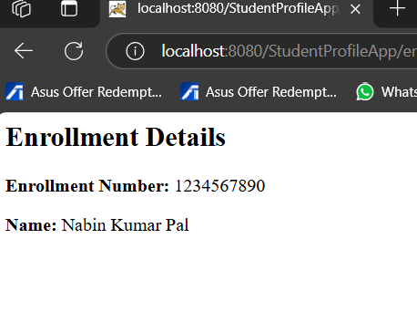

**Program No.9**

**Aim:**Write a HTTP Servlet program to display all the HTTP Request Header parameters.

**Code:**

Directory formate:

myapp

├── WEB-INF

│ ├── web.xml

│ └── classes

│ └── HeaderServlet.class

HeaderServlet.java:

import jakarta.servlet.*;

import jakarta.servlet.http.*;

import java.io.*;

import java.util.*;

public class HeaderServlet extends HttpServlet {

public void doGet(HttpServletRequest request, HttpServletResponse response) throws IOException, ServletException {

response.setContentType("text/html");

PrintWriter out = response.getWriter();

out.println("<html><head><title>HTTP Headers</title></head><body>");

out.println("<h2>HTTP Request Headers</h2>");

out.println("<table border='1' cellpadding='5'>");

out.println("<tr><th>Header Name</th><th>Header Value</th></tr>");

Enumeration<String> headerNames = request.getHeaderNames();

while (headerNames.hasMoreElements()) {

String header = headerNames.nextElement();

String value = request.getHeader(header);

out.println("<tr><td>" + header + "</td><td>" + value + "</td></tr>");

}

out.println("</table>");

out.println("</body></html>");

}

}

web.xml:

<web-app xmlns="https://jakarta.ee/xml/ns/jakartaee"

xmlns:xsi="http://www.w3.org/2001/XMLSchema-instance"

xsi:schemaLocation="https://jakarta.ee/xml/ns/jakartaee

https://jakarta.ee/xml/ns/jakartaee/web-app_5_0.xsd"

version="5.0">

<servlet>

<servlet-name>HeaderServlet</servlet-name>

<servlet-class>HeaderServlet</servlet-class>

</servlet>

<servlet-mapping>

<servlet-name>HeaderServlet</servlet-name>

<url-pattern>/headers</url-pattern>

</servlet-mapping>

</web-app>

**Output:**

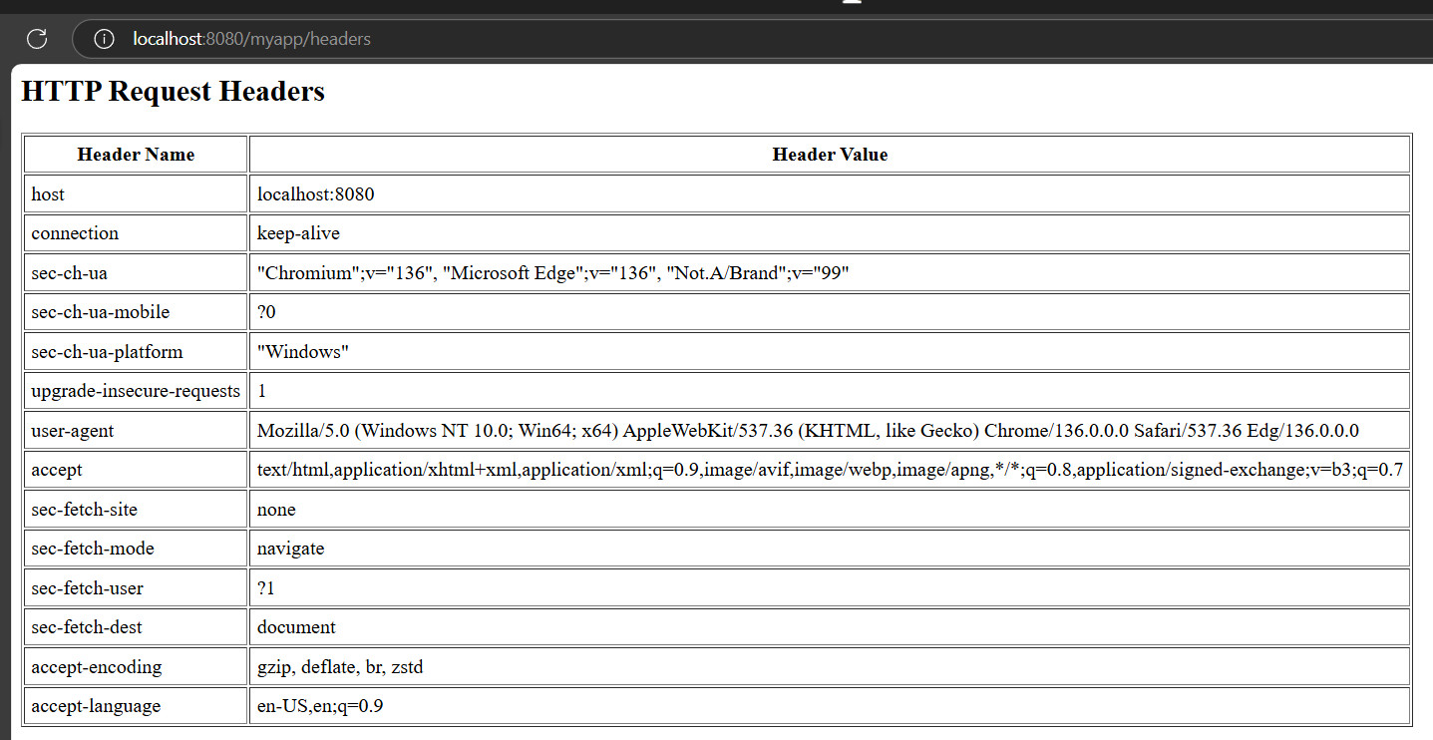

**Program No.10**

**Aim:**Write a HTTP Servlet program to create a Cookie.

**Code:**

Directory formate:

Myapp1

├── WEB-INF

│ ├── web.xml

│ └── classes

│ └── CreateCookieServlet.class

CreateCookieServlet.java:

import jakarta.servlet.*;

import jakarta.servlet.http.*;

import java.io.*;

public class CreateCookieServlet extends HttpServlet {

public void doGet(HttpServletRequest request, HttpServletResponse response)

throws ServletException, IOException {

response.setContentType("text/html");

PrintWriter out = response.getWriter();

Cookie myCookie = new Cookie("username", "NabinKumar");

response.addCookie(myCookie);

out.println("<html><body>");

out.println("<h2>Cookie Created Successfully!</h2>");

out.println("</body></html>");

}

}

web.xml:

<web-app xmlns="https://jakarta.ee/xml/ns/jakartaee"

xmlns:xsi="http://www.w3.org/2001/XMLSchema-instance"

xsi:schemaLocation="https://jakarta.ee/xml/ns/jakartaee

https://jakarta.ee/xml/ns/jakartaee/web-app_5_0.xsd"

version="5.0">

<servlet>

<servlet-name>CreateCookieServlet</servlet-name>

<servlet-class>CreateCookieServlet</servlet-class>

</servlet>

<servlet-mapping>

<servlet-name>CreateCookieServlet</servlet-name>

<url-pattern>/createcookie</url-pattern>

</servlet-mapping>

</web-app>

**Output:**

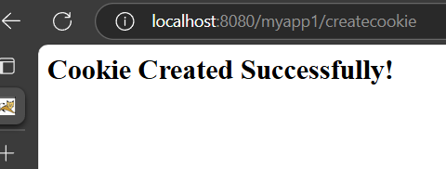

**Program No.11**

**Aim:** Write a JDBC Program to fetch the employees records from the Employee table designed in MS Access. The Table should have fields like: Employee ID, Name, DOB, Address, Department, DOJ, Position etc.

**Code:**

import java.sql.*;

public class FetchEmployeesMSAccess {

public static void main(String[] args) {

Connection conn = null;

try {

// Load UCanAccess JDBC driver

Class.forName("net.ucanaccess.jdbc.UcanaccessDriver");

String dbPath = "C:/Users//Documents/Employee.accdb";

String url = "jdbc:ucanaccess://" + dbPath;

conn = DriverManager.getConnection(url);

Statement stmt = conn.createStatement();

ResultSet rs = stmt.executeQuery("SELECT * FROM Employee");

while (rs.next()) {

System.out.println("ID: " + rs.getString("EmployeeID"));

System.out.println("Name: " + rs.getString("Name"));

System.out.println("DOB: " + rs.getDate("DOB"));

System.out.println("Address: " + rs.getString("Address"));

System.out.println("Department: " + rs.getString("Department"));

System.out.println("DOJ: " + rs.getDate("DOJ"));

System.out.println("Position: " + rs.getString("Position"));

System.out.println("-------------------------------");

}

rs.close();

stmt.close();

} catch (Exception e) {

System.out.println("Error: " + e);

} finally {

try {

if (conn != null) conn.close();

} catch (SQLException ex) {

ex.printStackTrace();

}

}

}

}

**Output:**

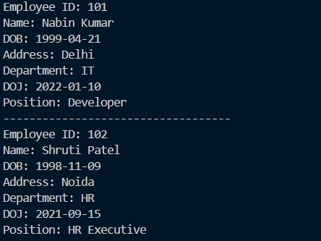

**Program No.12**

**Aim:** Create your portfolio website using LocalWP and WordPress.

**Output:**

